Time Entry Main Page

CALENDAR VIEW
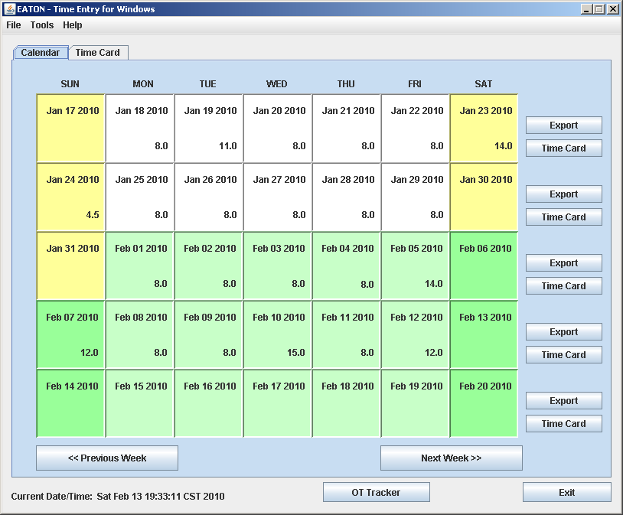
Menu Bar

View Selection

Export time card to file which can be imported by Oracle. A button for each week

Edit Time Card. A button for each week

Move to previous Calendar week Move to Next Calendar Week

OT Tracker Tool

Menu Bar

FILE
EXIT APPLICATION

TOOLS
SETTINGS SCREEN
IMPORT TIME CARD SCREEN
SEARCH DATABASE SCREEN
DATABASE MANAGEMENT
PROJECT REPORTS

HELP
HELP DOCUMENT (THIS DOCUMENT)
ABOUT

MAIN PAGE – TIME CARD VIEW
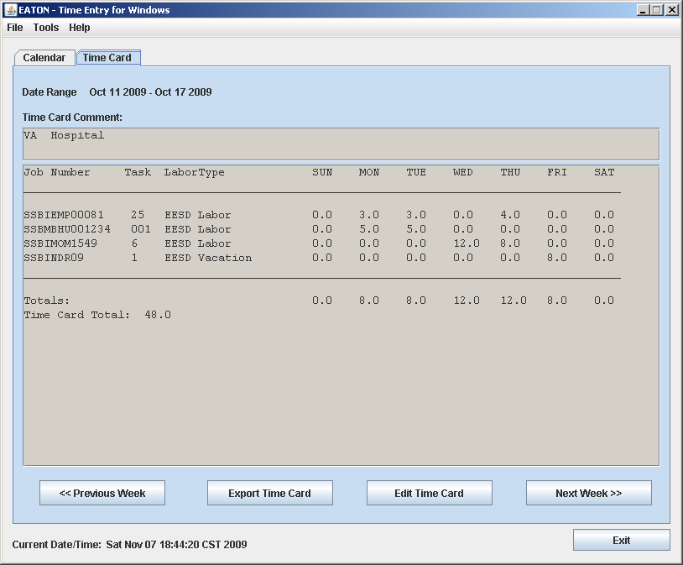
Date Range for Time Card

Time Card Comment Area

Time Card Line Entries

Export Time Card to Edit Time Card Being
File Oracle can Import Displayed

Menu Bar

FILE
EXIT APPLICATION

TOOLS
SETTINGS SCREEN
IMPORT TIME CARD SCREEN
SEARCH DATABASE SCREEN
DATABASE MANAGEMENT
PROJECT REPORTS

HELP
HELP DOCUMENT (THIS DOCUMENT)
ABOUT

Time Entry Settings Page
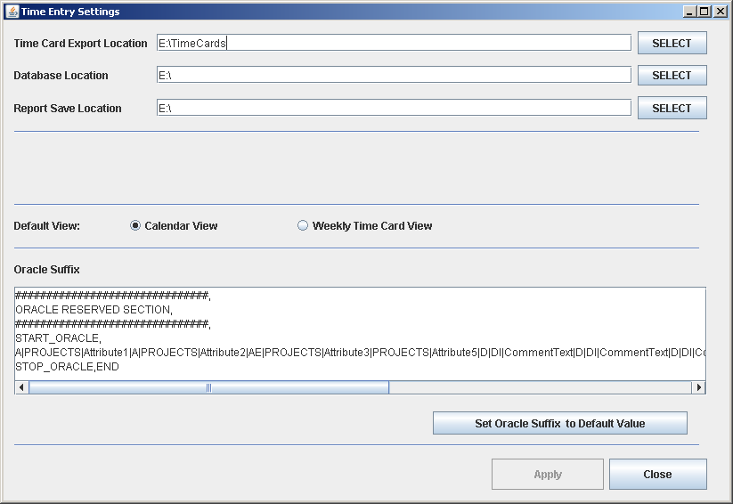
Set Folder where Time Entry will send the Oracle exported Files

Set folder where TE.MDB (main database) resides.

Set Location where search results will be saved

Set default view when
Time Entry program loads

Enter or set default Oracle string (required at bottom of exported time cards)

CALENDAR

